**Project Design Phase**

|  |  |
| --- | --- |
| **Date** | **22 June 2025** |
| **Team ID** | **LTVIP2025TMID20425** |
| **Project Name** | **LearnHub: Your Center for Skill Enhancement** |
| **Mentor Name** | **Dr Shaik Salma Begam** |
| **Maximum Marks** | **2 Marks** |

**Problem – Solution Fit**

**Problem–Solution Fit for LearnHub**

**Problem**

Students and professionals often struggle to find quality, structured, and affordable online courses tailored to their specific learning goals. Existing platforms are either too expensive, lack interactivity, or do not offer features like progress tracking, certification, or personalized learning paths. Furthermore, instructors and educational institutions face challenges in managing and delivering content effectively, tracking learner engagement, and offering timely support.

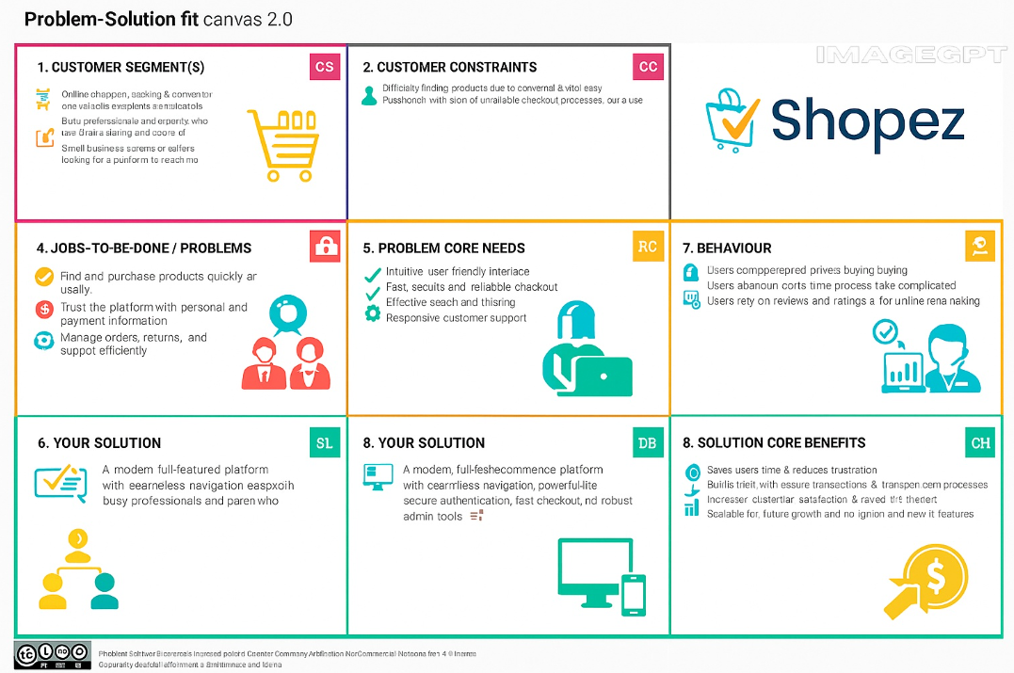**Solution**  
LearnHub provides a full-featured, easy-to-use, and scalable learning platform that bridges the gap between learners and educators. It offers course browsing, enrollment, progress tracking, certification, and discussion forums. For instructors and admins, it enables course creation, content management, student tracking, and analytics. LearnHub is designed to be accessible, customizable, and efficient for modern digital learning needs.

